Accel Project 2020 02 10

# Rotation operation

last week, failure of rotation operation, even on simulated data

* now fixed: problem in reshape operation associated with the matrix multiplication
* sample output: simulated data used a phi value of 0.8. Unclear what happened at iteration #23..

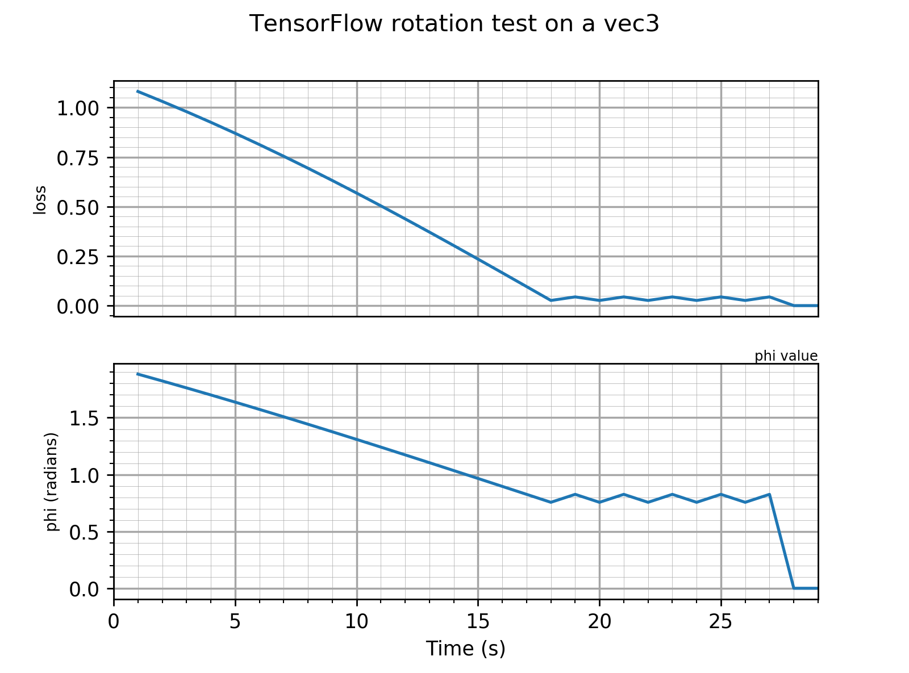

# Inference of radial parameter

* Jerome points out that our loss function, when combined with rotations, can involve square root of a negative number.
* Recall the loss
$c=\dot{a_{r}}-\frac{{\left(a_{t\left(i\right)}\right)}^{2}}{r}∆t-2a_{t\left(i\right)}\sqrt{\frac{a_{r\left(i\right)}}{r}}$

* a rotation of more than 90 degrees from the true angle will cause negative ar values. We need to customize how TF handles the phi value, must find a different angle if ar is negative.

# TODO

* more interesting synthetic data
  + piecewise constant; sawtooth and sinusoidal variations in alpha as a function of time.
* graph the loss field in 2D radial coordinates ( r and phi ).
* explore radial inference using hybrid data: so far not great..

# experimental team

* Calligraphy project
  + have written python code for automatically reconstructing positions from accelerations.
  + plotting in 3D.
  + encountering the problem of drift
  + have done “dash” and “slash”. Trying circles.
  + Seeking better-than-naive-integration methods to fix drift problem.
* TODO
  + Plot in 2D, ignoring z component
  + Produce an album of results using the naive method
  + Pedagogical elements for the poster presentation